AI ASSISTED CODING LAB

ASSIGNMENT 4.4

ENROLLMENT NO

:2503A51L33

BATCH NO:

20

NAME : Thirumalakonda shiva

TASK DESPRICTION 1: Auto-Complete a Python Class for Bank

* Write a class definition comment and start the constructor for a class

Account

called Bank Account with account_holder and balance attributes. Use

GitHub Copilot to auto-complete the rest of the class, including methods to deposit, withdraw, and display balance.

PROMPT 1: generate a Python class called Bank Account. Start with a class definition comment and a constructor that takes account_holder and balance as attributes. Then use GitHub Copilot to auto-complete the rest of the class with methods for depositing money, withdrawing money (with balance check), and displaying the current balance.

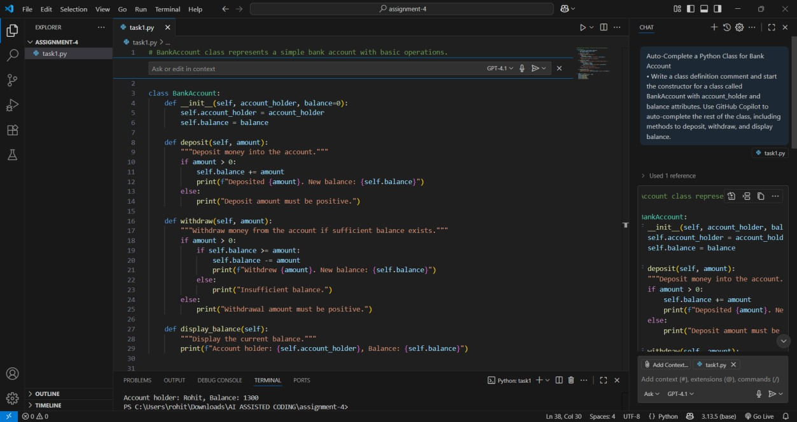

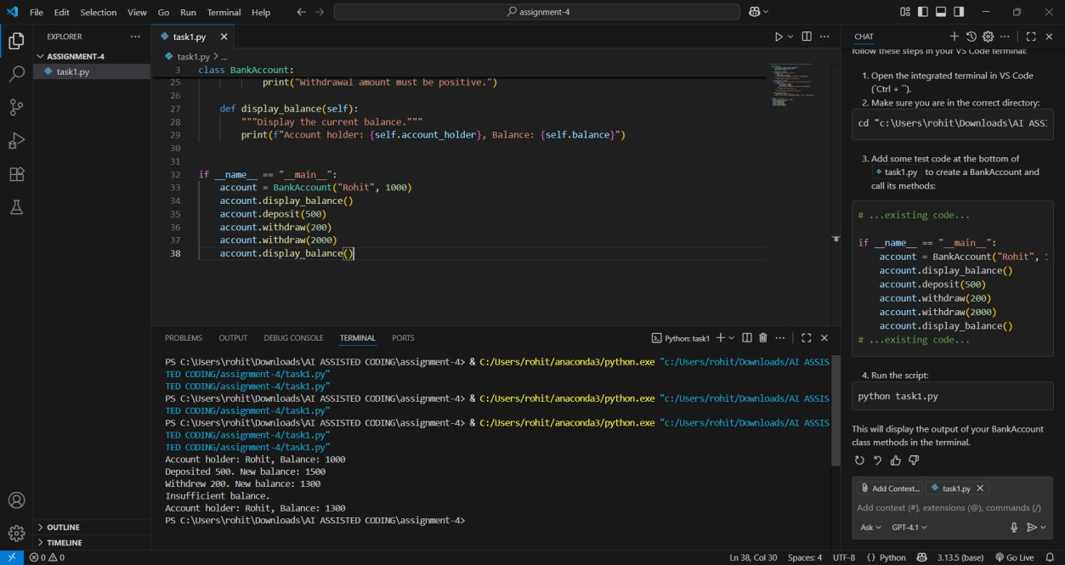

TASK DESCRIPTION 2: Auto-Complete a For Loop to Sum Even Numbers in a List

* Write a comment and the initial line of a loop to iterate over a list. Allow GitHub Copilot to complete the logic to sum all even numbers in the list.

PROMPT 1: generate a Python comment and start a for loop to iterate over a list of numbers. Then use GitHub Copilot to auto-complete the loop so that it sums all the even numbers in the list.

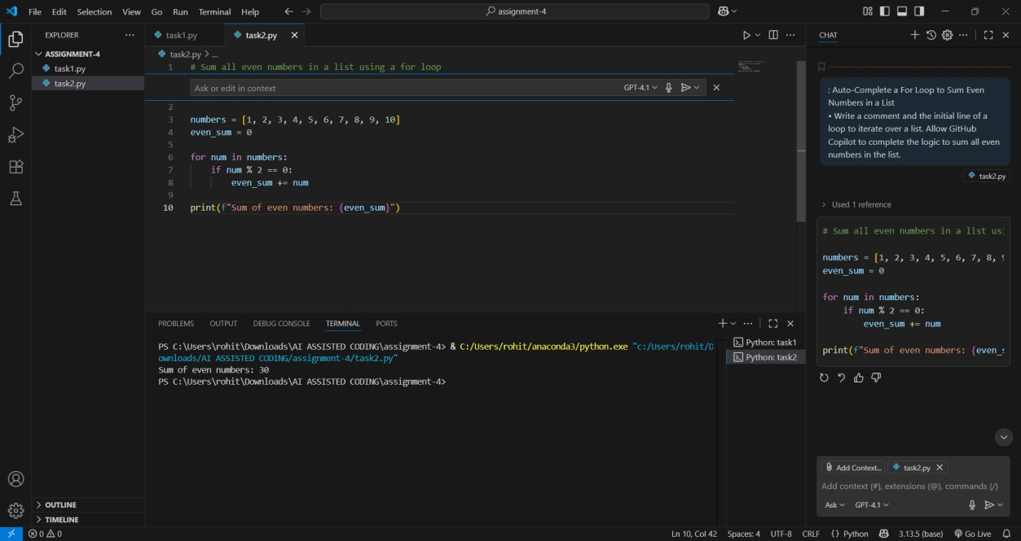

TASK DESCRIPTION 3: Auto-Complete Conditional Logic to Check Age Group

* Start a function that takes age as input and returns whether the person is a child, teenager, adult, or senior using if-elif-else. Use Copilot to complete the conditionals.

PROMPT 1: generate a Python function that takes age as input. Start the function definition and an if-elif-else structure, then use GitHub Copilot to auto-complete the logic so it returns whether the person is a child, teenager, adult, or senior."

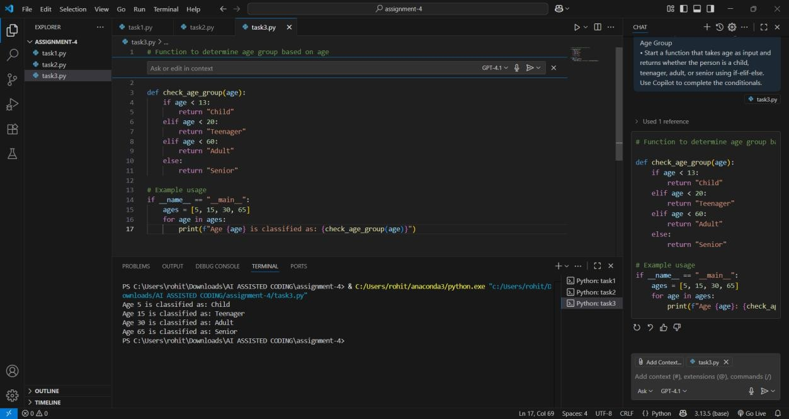

TASK DESCRIPTION 4: Auto-Complete a While Loop to Reverse Digits of a Number

* Write a comment and start a while loop to reverse the digits of a number. Let Copilot complete the loop logic.

PROMPT 1: generate a Python comment and start a while loop to reverse the digits of a number. Then use GitHub Copilot to auto-complete the loop logic.

PROMPT 1: generate a Python comment and start a while loop to reverse the digits of a number. Then use GitHub Copilot to auto-complete the loop logic.

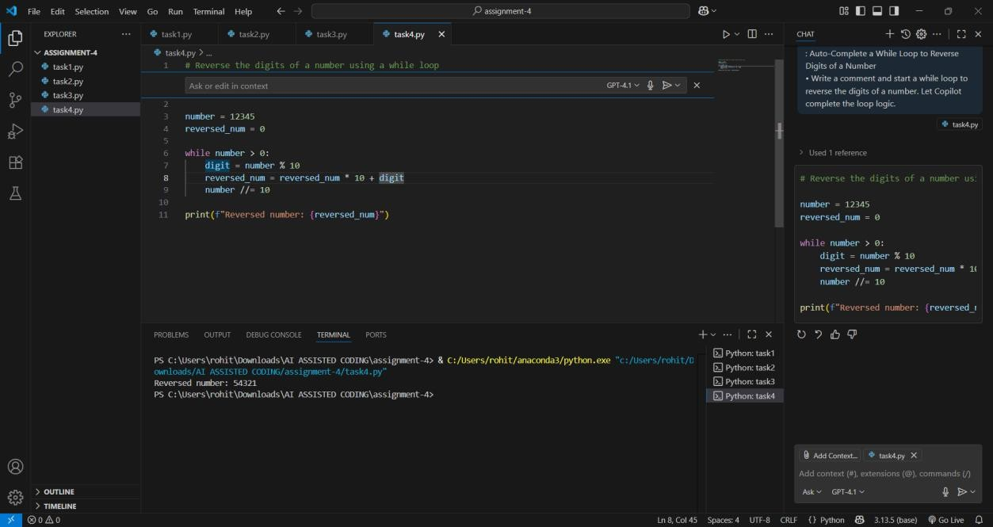

TASK DESCRIPTION 5: Auto-Complete Class with Inheritance (Employee → Manager)

* Begin a class Employee with attributes name and salary. Then, start a derived class Manager that inherits from Employee and adds a department. Let GitHub Copilot complete the methods and constructor chaining.

PROMPT 1: generate a Python class Employee with attributes name and salary. Then start a derived class Manager that inherits from Employee and adds a department attribute. Use GitHub Copilot to auto- complete the constructors and methods with proper inheritance and constructor chaining.

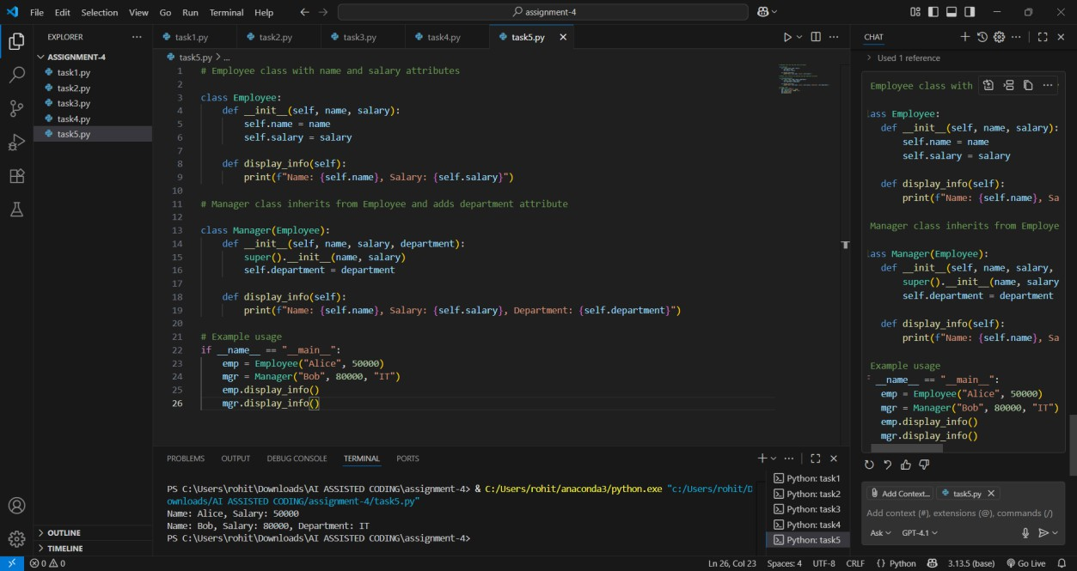

OBSERVATION: In this assignment, GitHub Copilot was effectively utilized to auto-completely different Python coding tasks. Each task was structured with a clear description and a starting prompt, allowing Copilot to generate the remaining logic. The tasks covered fundamental programming concepts such as class creation, loops, conditional statements, and inheritance. Specifically:

1. **Bank Account Class** – Demonstrated object-oriented programming with constructor, methods for deposit, withdraw, and balance display.
2. **For Loop for Even Numbers** – Showed how iteration and conditional checks can be automated for summing even numbers.
3. **Conditional Age Group Check** – Applied if-elif-else structure to classify age groups efficiently.
4. **While Loop for Reversing Digits** – Practiced loop control to reverse digits in a number.
5. **Class Inheritance (Employee → Manager)** – Illustrated constructor chaining and method overriding in object-oriented programming.